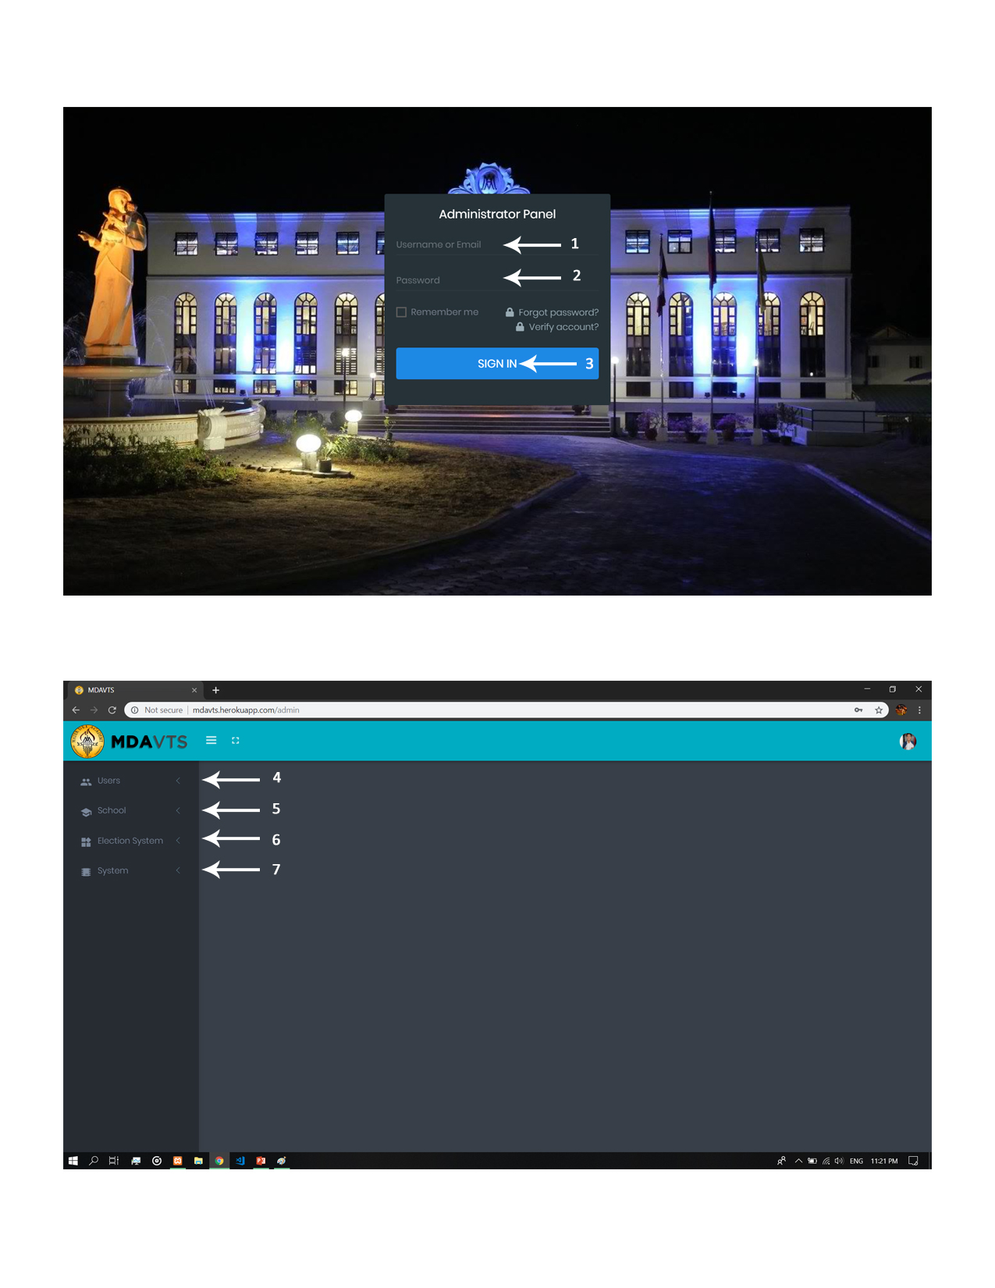

1. Username – this field must input valid username.
2. Password – the user must input valid password.
3. Sign-in Button – when the username and password field are valid you may proceed/click this button to sign-in in admin module.
4. User Tab – this tab contains the creation, deletion, and updating of users. The user has two type:

* Admin User – Acts as the COMELEC of the Election.
* User/Student – Also known as the voters for the Election Process.

1. School Tab – this tab contains the creation, deletion and updating of grade and section.
2. Election Tab – this tab contains the creation, deletion and updating of party lists, positions and information all about election.
3. System Tab – this tab contain the setting for the election procedure.

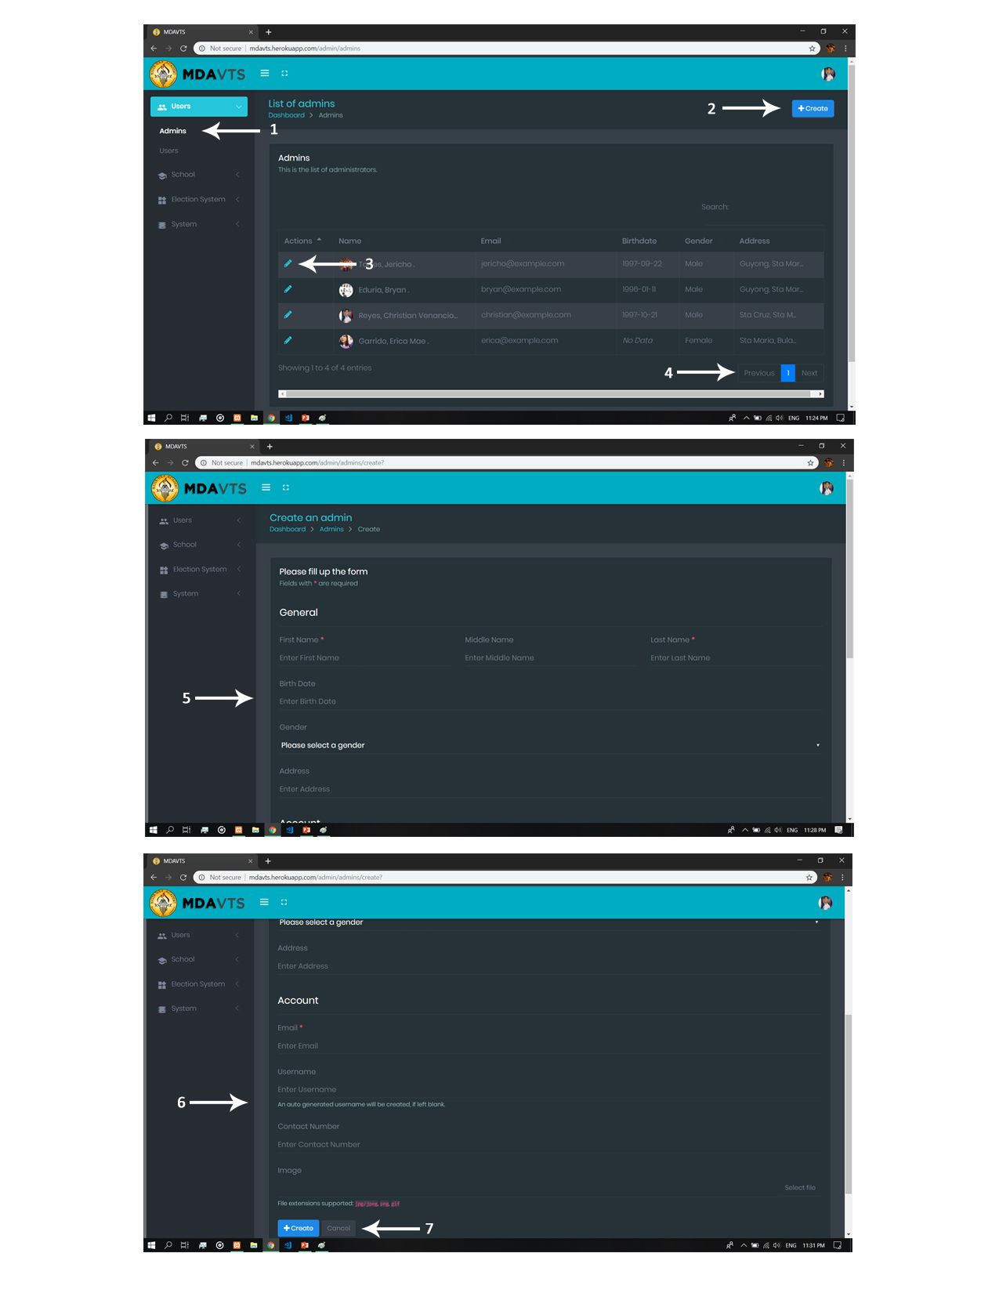

1. Admin Tab – this tab views all the information all about for the COMELEC officers.
2. Create Button – this button create an Admin User.
3. Edit Button – this button can update/modify your selected COMELEC officer’s information
4. Previous/Next Button – this button preview the next and previous list of the COMELEC officers.
5. General Information Sheet – this is all about the Admin General Information. It must bust filled before you can proceed.
6. Accounts Information Sheet – this is all about the Admin Accounts. It must bust filled before you can proceed.
7. Create/Cancel Button

* Create button – this button create a COMELEC officer for the election.
* Cancel button – this button undo/cancel your action made.

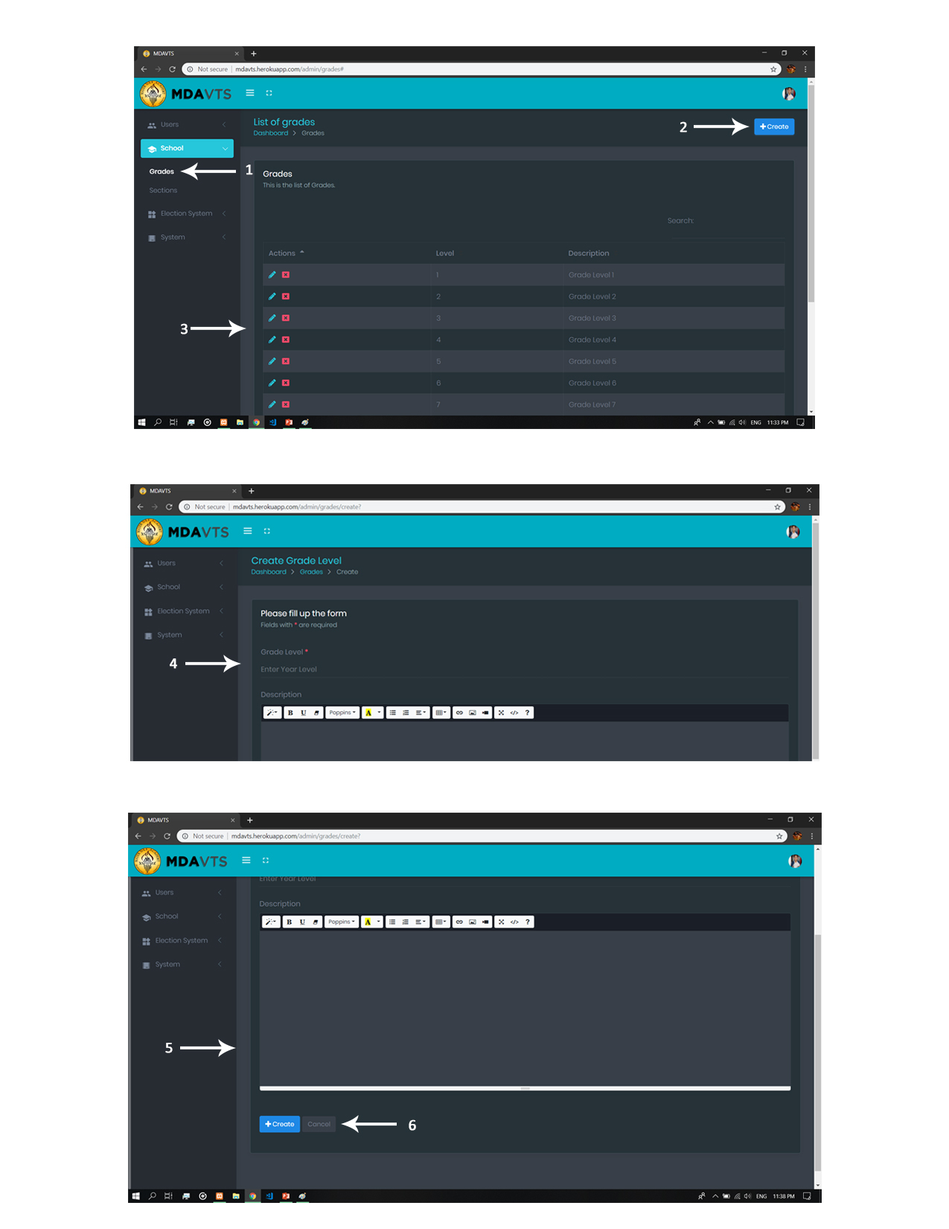

1. Grade Tab – this tab contains the creation, deletion and updating of Grade information.
2. Creation Button – this button create a Grade Level.
3. Edit and Delete Button

* Edit Button – this button update/modify the selected grade level information.
* Delete – this button delete the selected grade level information.

(Note: Once you delete you can undo the action you have been made.)

1. Grade Level Information Sheet – this is all about the Grade Levels. It must bust filled before you can proceed.
2. Description Text – this textbox must filled description all about your grade level want to create.
3. Create/Cancel Button

* Create button – this button create a Grade Level.
* Cancel button – this button undo/cancel your action made.

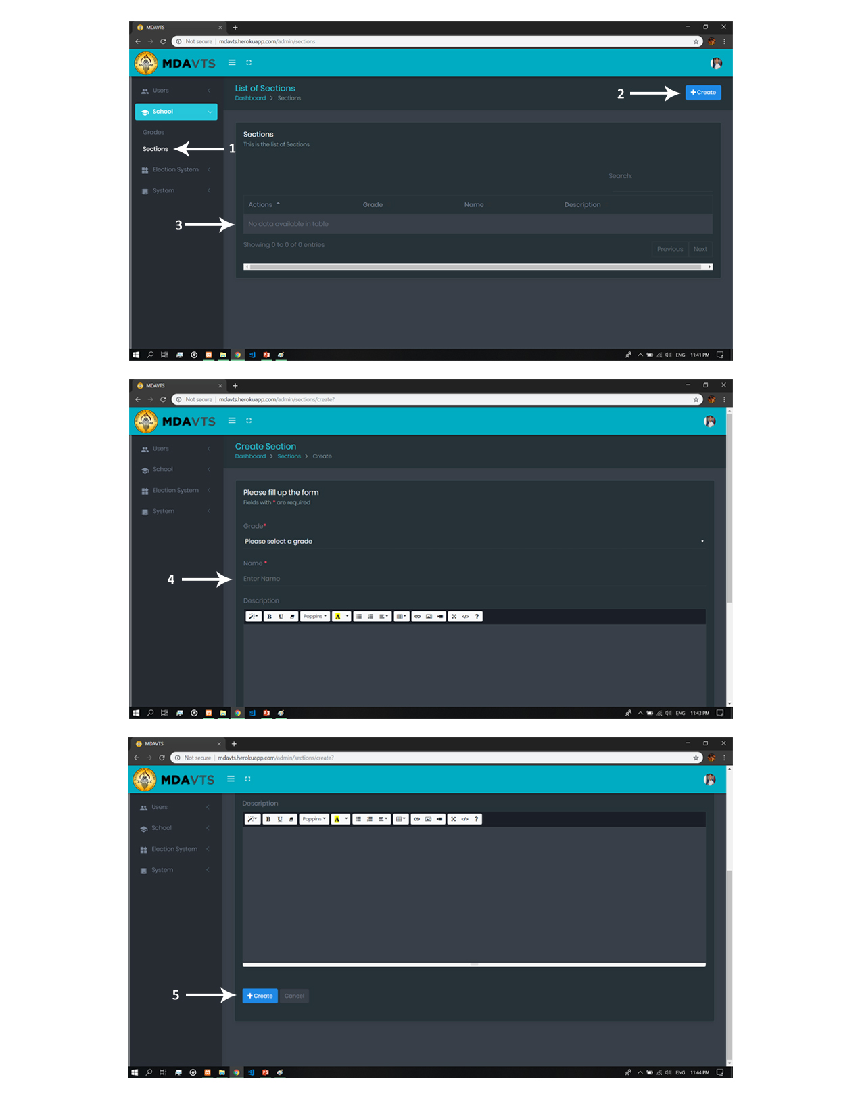

1. Section Tab – this tab contains the creation, deletion and updating of Sections.
2. Creation Button – this button create a Section for the designated Grade Level.
3. List View of Section – it display the list of sections.
4. Section Information Sheet – this is all about the sections. It must bust filled before you can proceed.
5. Create/Cancel Button

* Create button – this button create a Grade Level.
* Cancel button – this button undo/cancel your action made.

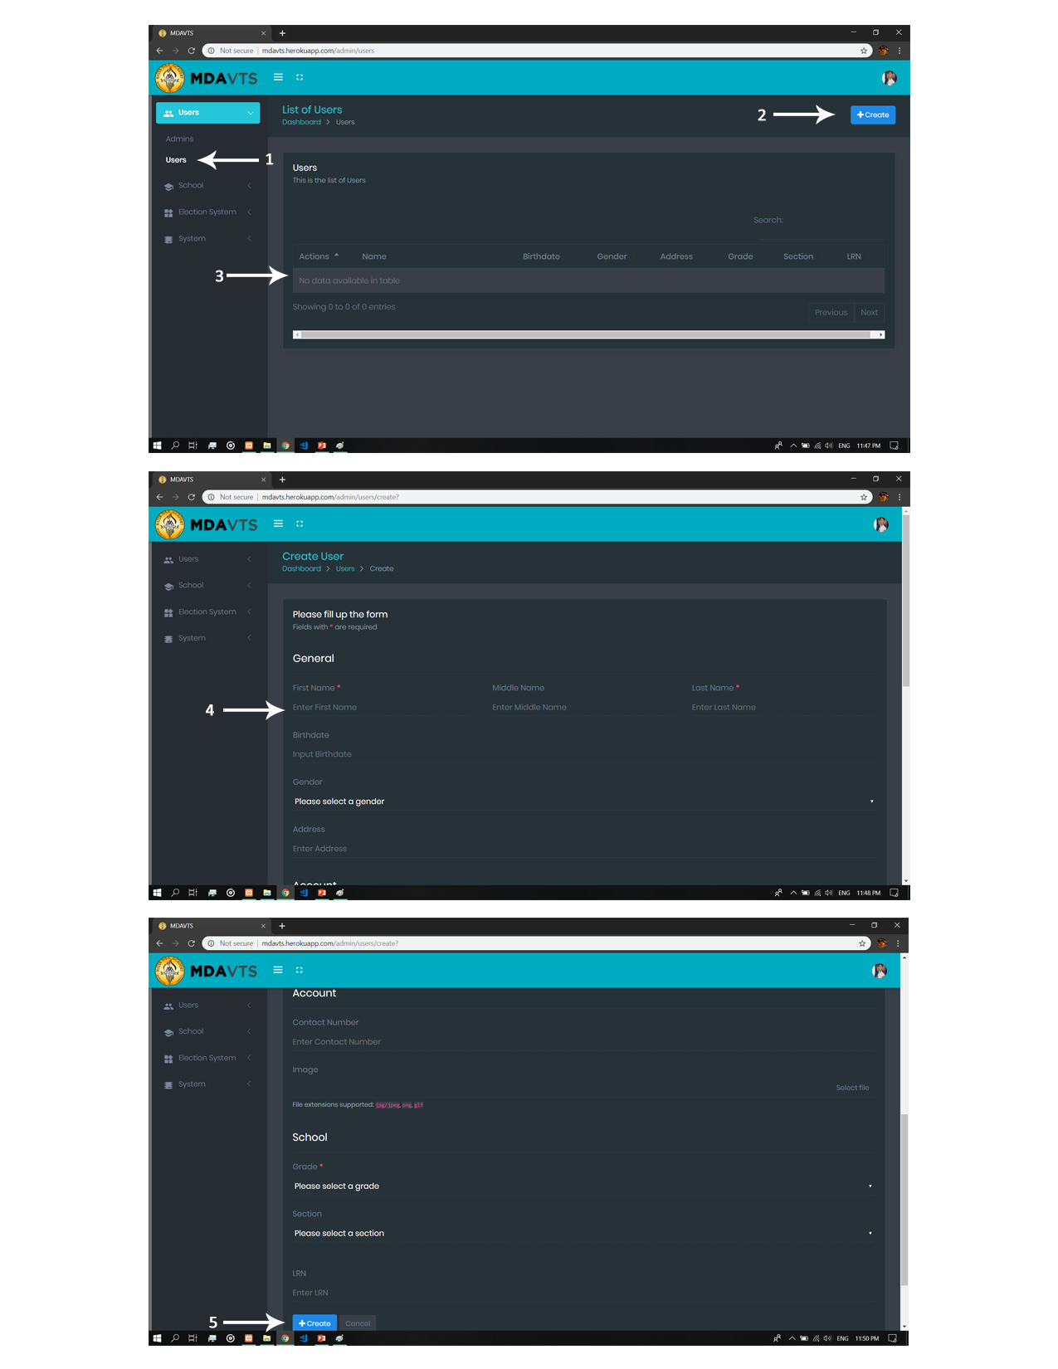

1. Users Tab – this tab contains the creation, deletion and updating of User also known as the students.
2. Creation Button – this button create a students.
3. List View of Students – it display the list of students.
4. Students Information Sheet – this is all about the sections. It must bust filled before you can proceed.
5. Create/Cancel Button
   * Create button – this button create a student.
   * Cancel button – this button undo/cancel your action made.

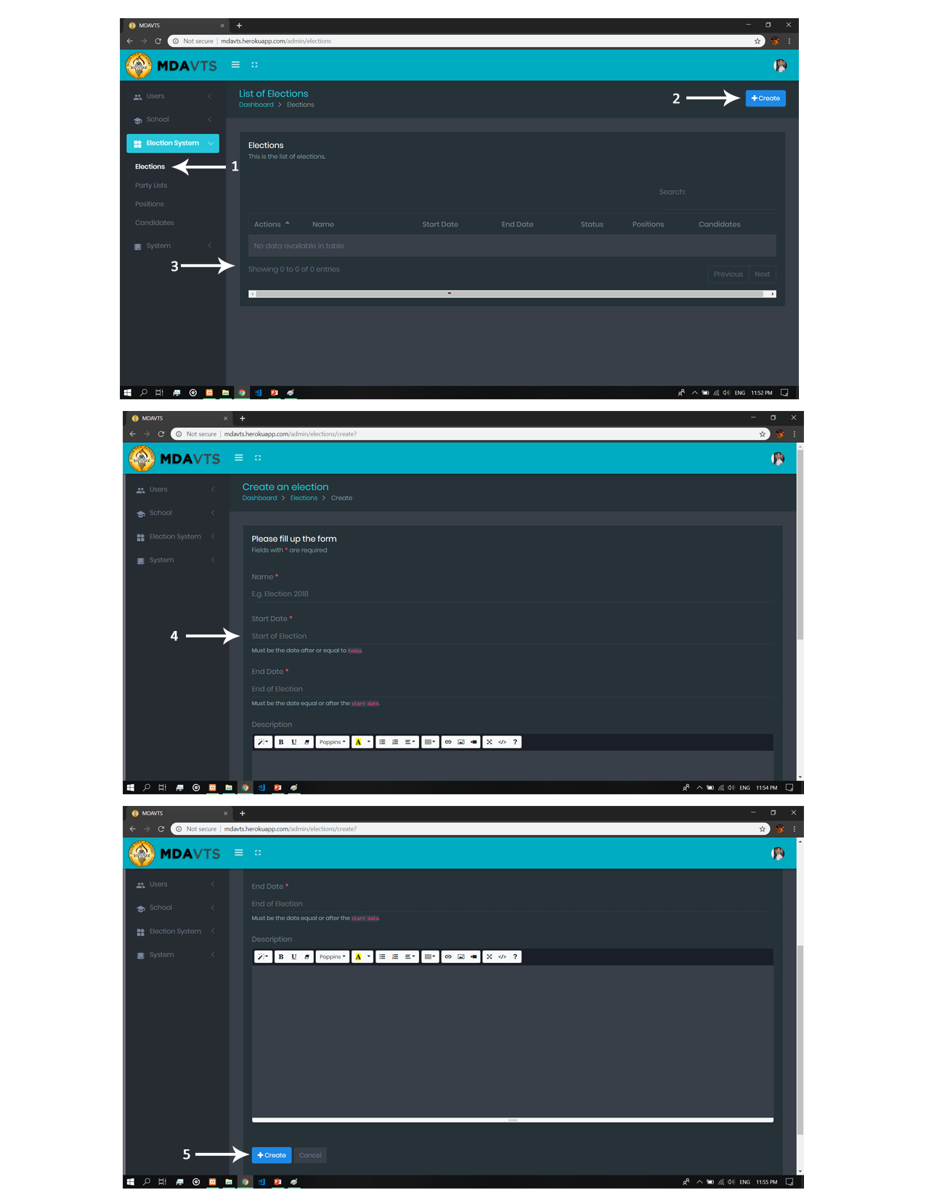

1. Elections Tab – this tab contains the creation and managing of Election.
2. Creation Button – this button create an Election.
3. List View of Election– it display the list of Upcoming, Active and Closed Election.
4. Election Information Sheet – this is all about the Election. It must bust filled before you can proceed.
5. Create/Cancel Button
   * Create button – this button create an Election.
   * Cancel button – this button undo/cancel your action made.

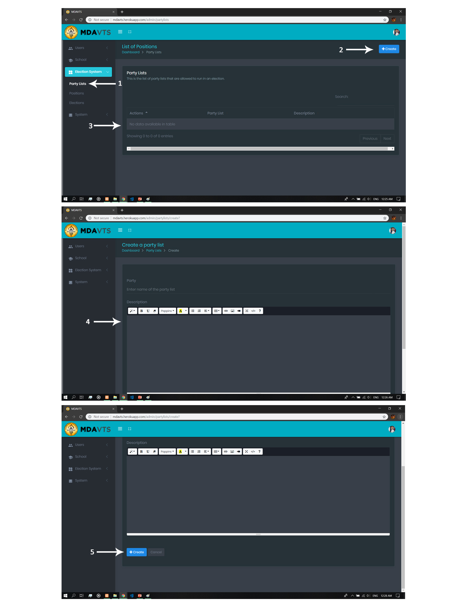

1. Party list Tab – this tab contains the creation, deletion and updating of party list.
2. Creation Button – this button create a party list.
3. List View of Party List – it display the list of Registered Party List.
4. Party List Information Sheet – this is all about the Party List. It must bust filled before you can proceed.
5. Create/Cancel Button
   * Create button – this button create a Party List.
   * Cancel button – this button undo/cancel your action made.

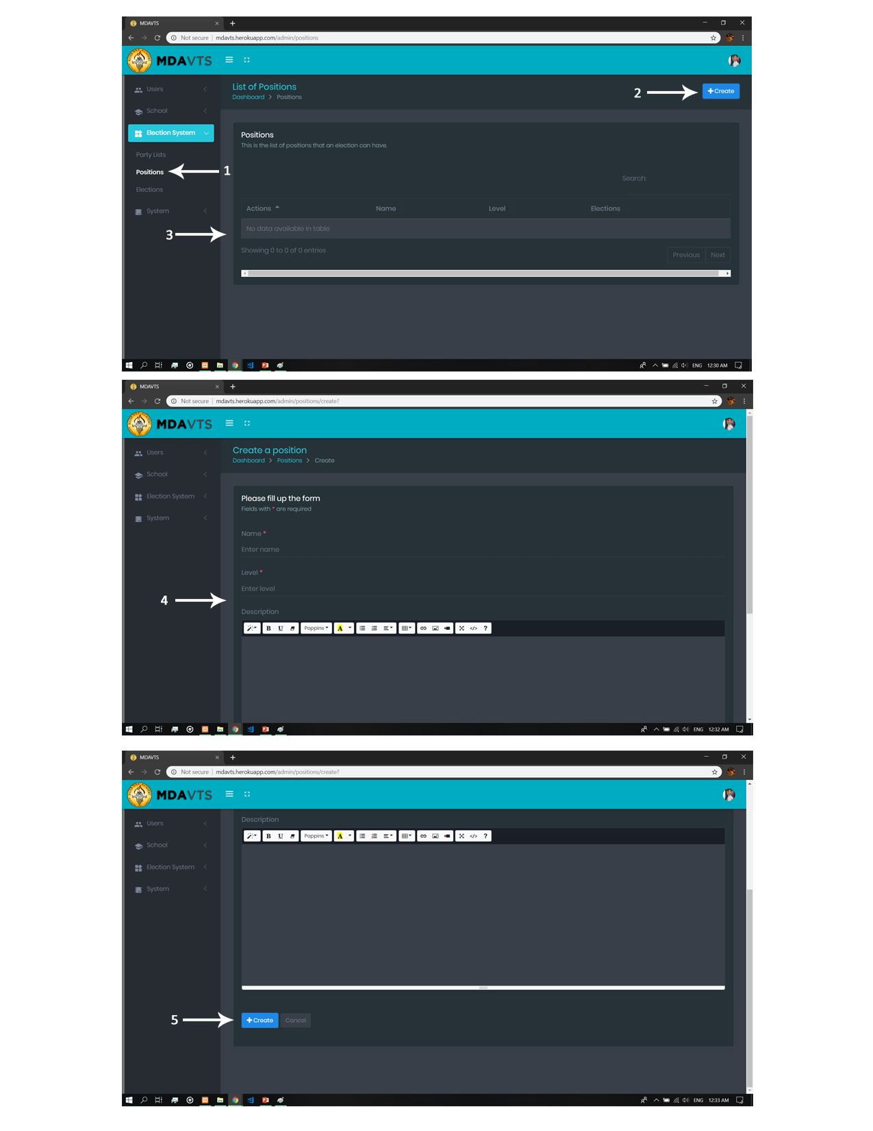

1. Position Tab – this tab contains the creation, deletion and updating of position.
2. Creation Button – this button create a position.
3. List View of Position – it display the list of Position.
4. Position Information Sheet – this is all about the position. It must bust filled before you can proceed.
5. Create/Cancel Button
   * Create button – this button create a position.
   * Cancel button – this button undo/cancel your action made.

